CpE 2211 Computer engineering lab
EXPERIMENT 4 lab manual
Revised: J. Tichenor FS19; J. Stanley SS25
multi-function gate design
OBJECTIVES
In this experiment you will
- Design, build, and document a Multi-Function Gate.
- Gain experience with use of Karnaugh Maps.
- Use the suite of EDA tools supplied by Altera: Quartus-II and QuestaSim.

LAB REPORTS
The format of lab reports should be such that the information can be used to reproduce the lab, including what values were used in a circuit, why the values were used, how the values were determined, and any results and observations made. This lab manual will be used as a guide for what calculations need to be made, what values need to be recorded, and various other questions. The lab report does not need to repeat everything from the manual verbatim, but it does need to include enough information for a 3rd party to be able to use the report to obtain the same observations and answers. Throughout the lab manual, in the Preliminary (if there is one), and in the Procedure, there are areas designated by Qxx followed by a question or statement. These areas will be bold, and the lab TA will be looking for an answer or image for each. These answers or images are to be included in the lab report. The lab TA will let you know if the lab report will be paper form, or if you will be able to submit electronically.
PURPOSE
The purpose of this exercise is to design, build, and document a Multi-Function Gate using small scale integration (SSI) components from a verbal description.
REFERENCES
CpE 2211 Laboratory Manuals: Appendix B and Appendix C.
Stanley and Woodley: Sections 2.1,2.2, 2.6
MATERIALS REQUIRED
Assorted SSI components (see Appendix C), Breadboard
BACKGROUND
The Multi-Function Gate, shown in the block diagram of Figure 1, can perform four different logical operations of the data inputs, A and B, controlled by the operation select inputs, X and Y, as shown in the function table of Figure 1. The specific logic function for each X, Y input pair will be given to you by your instructor.

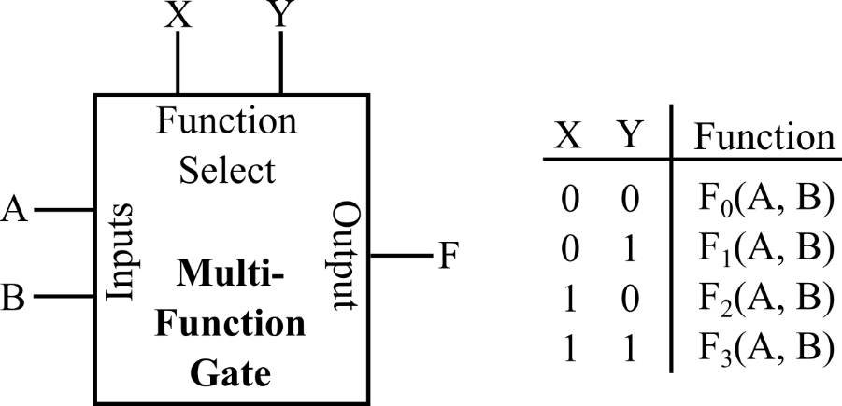

Figure 1: Block Diagram and Function Table for Multi-Function Gate.
PROCEDURE
- Represent the output F, as a function of A, B, X, and Y in a truth table.
- Write the minimal 2-level logic expressions for F using either a sum-of-products (SOP) or a product of-sums (POS).
- Draw a logic diagram for your SOP or POS expression.
- Draw a complete schematic diagram of the Multi-Function Gate in Quartus II, using as few SSI components and as few levels of logic as possible. The format for a schematic diagram is similar as shown in Appendix B, but with slightly difference.
- Simulate your design using QuestaSim. Print out the logic diagram, and the waveforms for all possible input combinations.

- Can invert be assigned as one of the functions of the Multi-Function Gate? If yes, explain how.
- Will a change in the number of outputs or data inputs affect the number of operation select lines? Explain.
- Will a change in the number of functions affect the operation select lines? Explain.
- How many unit loads does each input of your circuit present to gates that may drive them? One unit load is associated with each gate that must be directly driven by an input line. For example, the circuit in Appendix B has 3 unit loads for A, 3 for B, 3 for X, and 4 for Y.

